CS543 Assignment 4

**Your Name:** Siyu Ren

**Your NetId:** siyuren2

# Part 1 Single-View Geometry:

**​​Plot the VPs and the lines used to estimate them on the image plane using the provided code.**

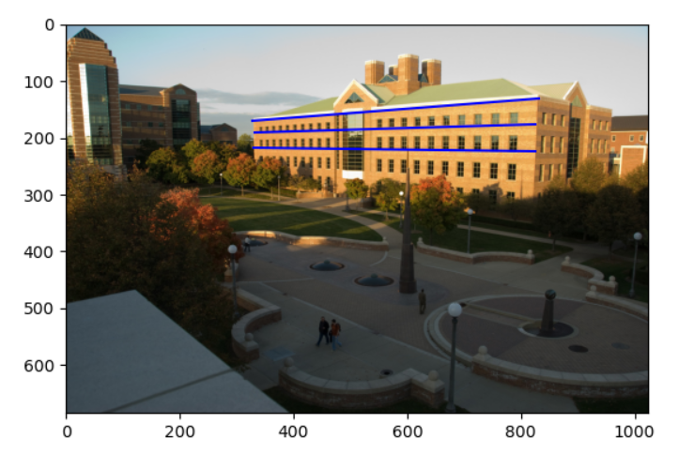

**Specify the VP pixel coordinates.**

[-203.3285479 209.35966912 1. ]

[1.37067514e+03 2.20868604e+02 1.00000000e+00]

[5.34152552e+02 6.37249215e+03 1.00000000e+00]

**Plot the ground horizon line and specify its parameters in the form a * x + b * y + c = 0. Normalize the parameters so that: a^2 + b^2 = 1.**

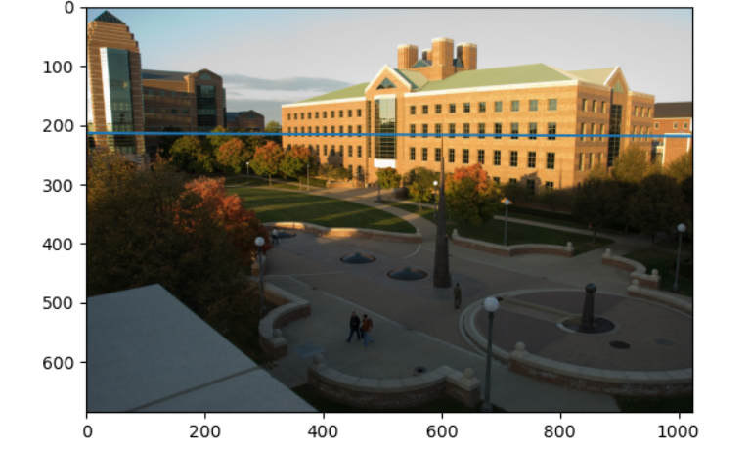

[-5.12898158e-03 9.99986847e-01 -2.13217329e+02]

**Using the fact that the vanishing directions are orthogonal, solve for the focal length and optical center (principal point) of the camera. Show all your work.**

f = 771.233799695055, u = 554.681767883752, v = 265.971208360832

Here I used SymPy to solve the equation for value of f, u, and v. I apply the formula

We have

v1.T * inverse_K.T * inverse_K * v2 = 0

v1.T * inverse_K.T * inverse_K * v3 = 0

v2.T * inverse_K.T * inverse_K * v3 = 0

Use the solve() function of Sympy to get the results.

**Compute the rotation matrix for the camera.**

[[ 0.69941661 -0.00511828 -0.71469589]

[-0.04257925 0.99789983 -0.04881539]

[ 0.71344476 0.06457351 0.69772978]]

**Estimate the heights of (a) the CSL building, (b) the spike statue, and (c) the lamp posts assuming that the person nearest to the spike is 5ft 6in tall. In the report, show all the lines and measurements used to perform the calculation**.

Estimating height of CSL building

Height of CSL building is 1041.235449646049 inches

Estimating height of the spike statue

Height of the spike statue is 358.99447359410595 inches

Estimating height of the lamp posts

Height of the lamp posts is 164.47121356304896 inches

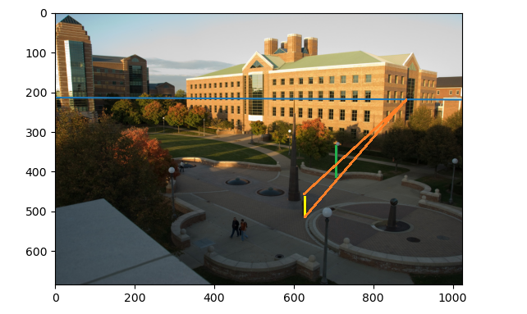

**How do the answers change if you assume the person is 6ft tall?**

Height of CSL building is 1135.8932177956897 inches

Height of the spike statue is 391.63033482993376 inches

Height of the lamp posts is 179.4231420687807 inches

# Part 2 Fundamental Matrix Estimation, Camera Calibration, Triangulation:

## **For the lab and library image pairs, display your result (points and epipolar lines) and report your residual for both unnormalized and normalized fundamental matrix estimation.**

## **Lab:**

Normalized Residual = 0.6172517559032137

Unnormalized Residual = 2.2379774253496825

## **Library:**

Normalized Residual = 0.18359661716194822

Unnormalized Residual = 0.33849509606031347

## **For the lab image pair, show your estimated 3x4 camera projection matrices. Report the residual between the projected and observed 2D points.**

## matrix1 =

## [[ 3.09971524e-03 1.46250174e-04 -4.48354919e-04 -9.78974905e-01]

## [ 3.06744636e-04 6.36810842e-04 -2.77389022e-03 -2.03932211e-01]

## [ 1.67995219e-06 2.74565792e-06 -6.83395792e-07 -1.32842138e-03]]

matrix2 =

[[-6.88970692e-03 3.96429852e-03 1.39263702e-03 8.28289829e-01]

[-1.53909600e-03 -1.02084411e-03 7.22962251e-03 5.60181867e-01]

[-7.58603647e-06 -3.72293087e-06 2.03836990e-06 3.38133189e-03]]

Residual1 = 13.765505109334178

Residual2 = 17.781125905791964

## **For the lab and library image pairs, visualize 3D camera centers and triangulated 3D points.**

## lab1_center = [305.83387882 304.20073002 30.13782356 1. ]

## lab2_center = [303.14001018 307.21161306 30.4296492 1. ]

## library1_center = [ 7.28863053 -21.52118112 17.73503585 1. ]

## library2_center = [ 6.89405488 -15.39232716 23.41498687 1. ]

**Labs Plot of camera centers and triangulated 3D points:**

residual1 = 2.9569700754132855

residual2 = 0.08726077273043897

**Library Plot of camera centers and triangulated 3D points:**

residual1 = 0.07312796424284178

residual2 = 0.2676795126176233

## **For the house and gaudi image pairs, display your result and report your number of inliers and average inlier residual for normalized estimation without ground truth matches.**

## House:

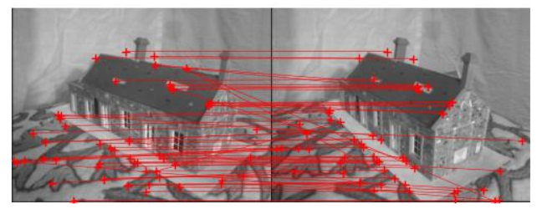

Number of inliers: 62, Average residual: 0.10088909946076352

Gaudi

## 

## Number of inliers: 92, Average residual: 0.25208323102180274

# Extra Credit:

Don’t forget to include references, an explanation, and outputs to receive credit. Refer to the assignment for suggested outputs.

**Part 1**

**Perform additional measurements on the image: which of the people visible are the tallest?**

Here I used the same person as reference with height 66 inch.

The output is as followed (May be inaccurate due to manual operation):

Estimating height of person2

Height of person2 is 56.22517429917324 inches

Estimating height of person3

Height of person3 is 41.718546216727624 inches

Estimating height of person4

Height of person4 is 54.53714182078599 inches.

Therefore, the highest person should be the person next to the spike statue.